# DAISY

# DAISY LICENSE KEY :

Hence forth user will need only valid license Key to use Daisy Product. Daisy license key will be freely available for internal PSL teams.

The License Key will be specific to the particular System where it will be generated and validated. The User will not be able to use the same License Key on any other system of their organization.

**Objective**:

**Manual to generate License Key and to validate it against Client machine.**

**Process:**

**Step No 1:**

User or Client will need to run the **./RunDaisy.sh -requestlic** on the particular system where they will be using Daisy Product.

**Step No 2:**

User need to enter details like Project Name, Contact Person Name, Email_ID. The System details like HostName, Machine Address and Current Date will be automatically generated.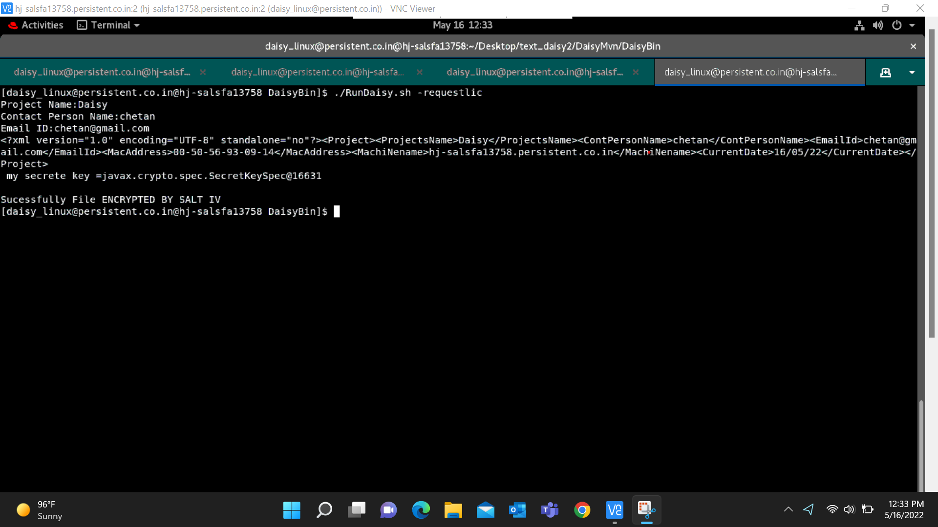

**Step No** 3:

The **Cust_Data.enc** file will be created in DaisyBin from the above details and the file will be encrypted by Salt IV will be generated.

**Step No 4:**

The User will Share the Cust_Data.enc file with the Daisy POC.

**Step No.6:** Now POC will share **Daisy_HostName.lic** with Client and Client will put lic file in DaisyBin folder to use Daisy.

**Step No.7:** Client need to give permission to Linux system for execution of RunDaisy.sh script file, use following command:

“**chmod u+x RunDaisy.sh**”

**Troubleshooting**

**Solutions to above problems if above steps aren’t executed properly.**

1. "Machine_Name.lic" file which contains invalid key:

1. DaisyBin NOT contains "Machine_Name.lic". It will indicate DaisyBin folder isn’t have .lic file in it.

1. If file Daisy.Lic fileName is written correctly and valid then:

